2023 Eagles Wrestling Camps
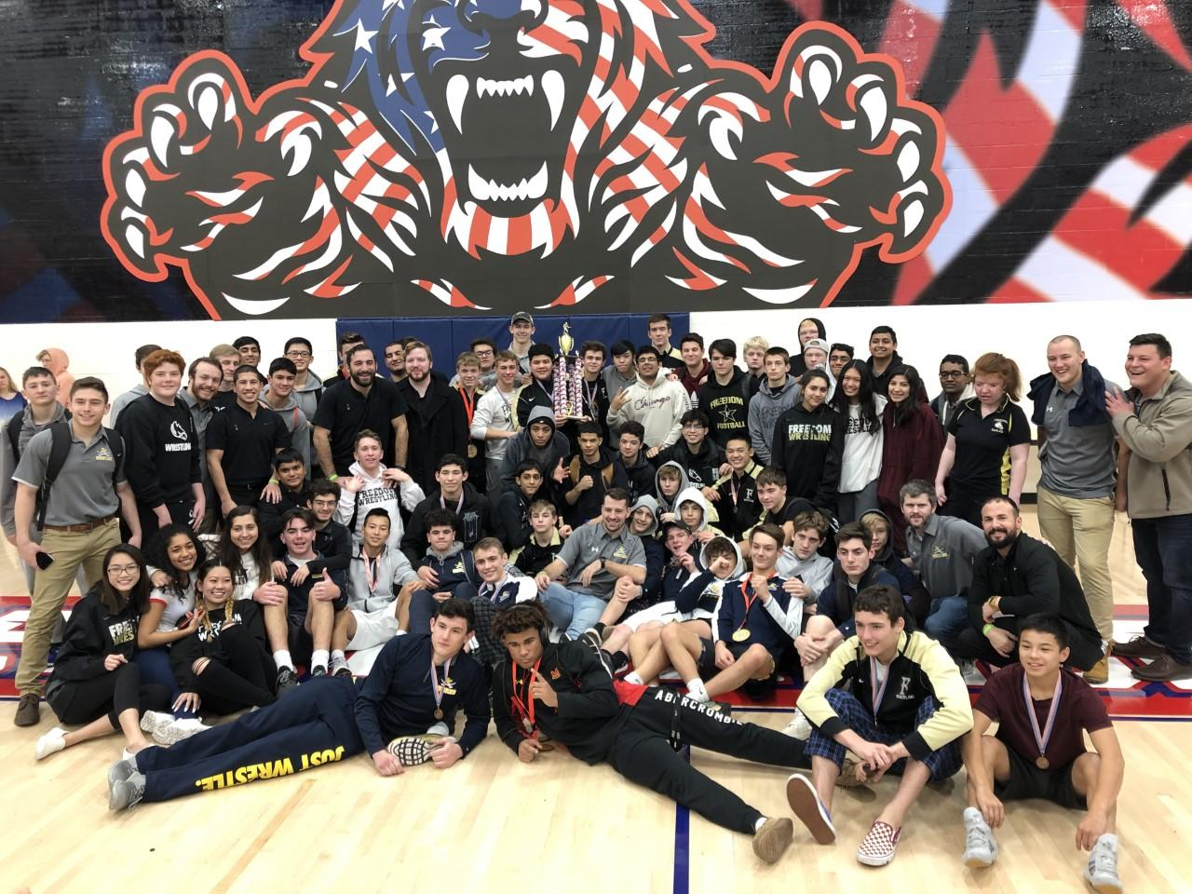
Dates- June 26 – June 30
Location- Ranger Wrestling Club (960 Sycolin Rd Suite 125, Leesburg, VA 20175)
Times- 8am-12pm (K-6), 12pm- 4:30pm (7-12)
Cost- $150
Format- The wrestlers will have multiple training sessions per day (with games mixed in) to focus on skill sets from all positions (Top, Bottom, Neutral). We will also work on specialty skill sets (leg riding, tilts, scrambling, throws). Perfect for any level of wrestler from beginner to very experienced.

Enrollment-

Two Great Camps/One Low Price ($150)

Eagles Wrestling Camp (K-6) 8am-12pm - This camp, conducted by Freedom's Coaching staff, is for grades k-through 7. The focus of this camp is to concentrate on the fundamentals of wrestling from the top, bottom and neutral positions. Athletes will be taught a variety of techniques designed to help them become a championship wrestler. Athletes will also wrestle live, participate in wrestling games, and have guest speakers designed to help them better learn and appreciate the sport of wrestling. Register HERE

Eagles Alumni Camp (7-12) 12pm - 4:30pm - This Camp, conducted by Freedom Alumni/Coaching Staff and is for grades 7-rising 12th graders. The focus of the camp is to create championship level wrestlers. The camp will focus mostly on new techniques from the top, bottom and neutral position. Athletes will also wrestle live, participate in wrestling games, and have guest speakers designed to help them better learn and appreciate the sport of wrestling. All levels of experience including beginners are welcome to attend, given that the boys will be divided into different learning groups. Register HERE
Camp Clinicians (Past and Present)
Greg Northart- Head Wrestling Coach Freedom High School (Camp Director)
Kent Nagy- Assistant Wrestling Coach Loudoun County High School
Paul Grinups - Head Coach Independence, VA State Champion
Tanner Cooley - Head Coach Broad Run High School
Jason Cardozo- Coach Freedom High School, Freedom High School Alumni
Steven Marquina- Coach Freedom High School, Freedom High Alumni, 2x District Champ
Michael Hosti- Coach Freedom High School, 2x District Champion, All State wrestler
Wes Reeves - Coach Freedom High School, District Champion, Region Runner-up, 2 x All-State
Jack Wrenn- Loudoun County Wrestling Coach, Regional qualifier, wrestled at Ferrum College
Matt Murphy- Head Wrestling Coach, 3x Regional Qualifier
Nicky Scolarici - Ast Coach Loudoun County, District Champion, Region Champion, Fargo Qualifier
Bryan Guzman - District & Region Champion, Fargo National qualifier, Wrestler for Shenandoah Univ.
And Many Other Decorated Wrestlers
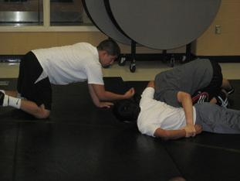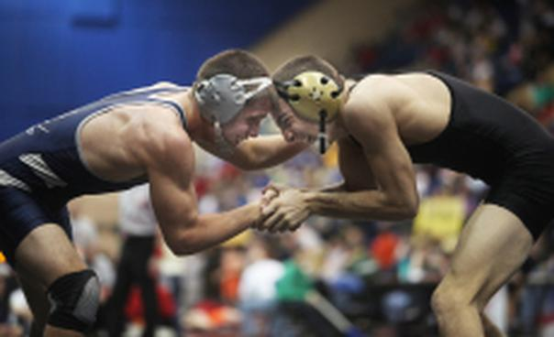
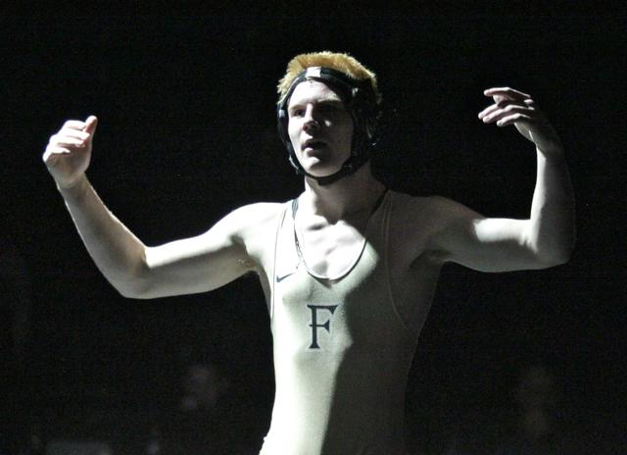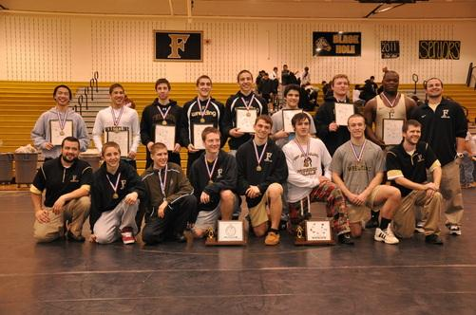

Come train like an Eagle

5x LCPS Champions 2015, 2016, 2017, 2018, 2019
2x Regional Champions 2019, 2020 (3 Runner-ups)
5 Conference/District Titles 2010, 11, 12, 14, 18 (7 Runner-Ups)
311-113 Overall Dual meet Record
49 Individual Conference/District Champions
76 Regional Place Winners
36 State Medal Winners

